

Tech Saksham
Case Study Report

Data Analytics with Power BI

Analysis of commercial electricity consumption in Indian State

SRI PARAMAKALYANI COLLEGE, ALWARKURICHI

NM ID | NAME
0040F6253B4C1D69B2847417B6C19DD4 | NANDHINI S

Trainer Name: R UMAMAHESWARI

Master Trainer: R UMAMAHESWARI





ABSTRACT


This study examines commercial electricity consumption patterns in an Indian state. It analyzes factors influencing consumption, such as business size, sectoral composition, and geographic location. Using statistical methods and data visualization, the research identifies trends and potential areas for optimization.


INDEX

Sr. No. | Table of Contents | Page No.
1 | Chapter 1: Introduction | 4
2 | Chapter 2: Services and Tools Required | 6
3 | Chapter 3: Project Architecture | 8
4 | Chapter 4: Modeling and Result | 10
5 | Conclusion | 15
6 | Future Scope | 16
7 | References | 17
8 | Links | 17


CHAPTER 1

INTRODUCTION

1.1 Problem Statement

Analyze the commercial electricity consumption trends in a specific Indian state over a designated period. This analysis aims to provide insights into the usage patterns, demand fluctuations, and potential factors influencing commercial electricity consumption within the state. Key objectives include identifying peak consumption periods, assessing seasonal variations, exploring correlations with economic indicators or policy changes, and proposing recommendations for optimizing energy usage efficiency and infrastructure planning.

1.2 Proposed Solution

The proposed solution involves analyzing historical commercial electricity consumption data for a specific Indian state. Through data preprocessing, exploratory data analysis, and time series analysis, patterns, trends, and influencing factors will be identified. Regression analysis and machine learning models will be employed to predict future consumption and assess the impact of various scenarios. A comprehensive report, supported by visualizations, will communicate key insights and recommendations for effective decision-making.

1.3 Feature

- Historical Consumption Trends: Analyze historical data to identify patterns, trends, and seasonality in commercial electricity consumption over time.

© Edunet Foundation. All rights reserved |1
- Policy and Regulatory Influence: Evaluate the effect of government policies, regulations, and incentives on commercial electricity usage.

- Sector-specific Analysis: Examine consumption patterns across different commercial sectors to identify sector-specific drivers.

- Predictive Modeling and Forecasting: Develop predictive models using advanced techniques such as time series analysis or machine learning to forecast future electricity consumption.

1.4 Advantages

- Resource Optimization

- Cost Reduction

- Policy Effectiveness

- Infrastructure Planning

- Risk Management

- Environmental Impact

1.5 Scope

The scope of analyzing commercial electricity consumption in an Indian state involves examining historical and current data to understand consumption trends across various sectors. It includes assessing factors such as demographic changes, economic indicators, policy influences, and technological advancements. By employing analytical techniques and forecasting methods, stakeholders can gain insights into future demand patterns and make informed decisions to optimize energy usage, promote sustainability and ensure reliable electricity supply.

© Edunet Foundation. All rights reserved |2

CHAPTER 2

SERVICES AND TOOLS REQUIRED

2.1 Services Used

- Data Analytics Platforms: Utilizing platforms like Python's pandas library, R programming language, or MATLAB for data manipulation, statistical analysis, and visualization, enabling analysts to process and analyze large datasets of electricity consumption efficiently.

- Geospatial Analysis Tools: Leveraging tools such as QGIS or ArcGIS for geospatial analysis, allowing analysts to visualize and interpret electricity consumption patterns across different geographic regions within the Indian state, aiding in understanding localized trends and variations.

- Machine Learning Platforms: Employing machine learning platforms like scikit-learn in Python or TensorFlow for building predictive models to forecast future electricity consumption trends and identify factors influencing consumption behavior, enabling stakeholders to make data-driven decisions for energy management and infrastructure planning.

2.2 Tools and Software used

Tools:

- Power BI: The main tool for this project is Power BI, which will be used to create interactive dashboards for data visualization.

© Edunet Foundation. All rights reserved |3
- Power Query: This is a data connection technology that enables you to discover, connect, combine, and refine data across a wide variety of sources.

Software Requirements:

- Power BI Desktop: This is a Windows application that you can use to create reports and publish them to Power BI.

- Power BI Service: This is an online SaaS (Software as a Service) service that you use to publish reports, create new dashboards, and share insights.

- Power BI Mobile: This is a mobile application that you can use to access your reports and dashboards on the go.

CHAPTER 3

PROJECT ARCHITECTURE

3.1 Architecture
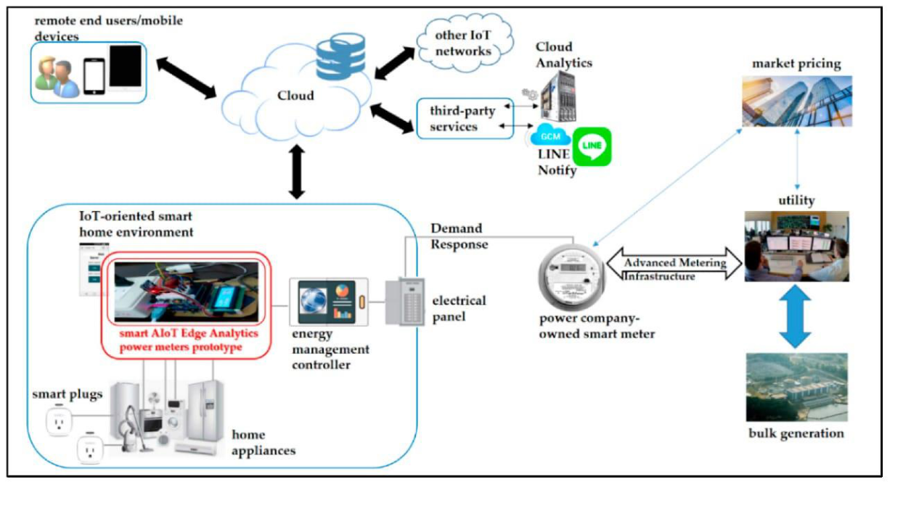

© Edunet Foundation. All rights reserved |4

- Data Collection: Obtain electricity consumption data from commercial establishments in the target state. This data may be available from government agencies, utility companies, or through surveys.

- Data Preprocessing: Clean and preprocess the data to handle missing values, outliers, and inconsistencies. This step may also involve data normalization or transformation.

- Feature Engineering: Extract relevant features from the data, such as time of day, day of week, seasonality, and any other factors that may influence commercial electricity consumption.

- Exploratory Data Analysis (EDA): Conduct EDA to understand patterns, trends, and correlations in the data. This step helps in gaining insights and identifying potential relationships between variables.

- Model Selection: Choose appropriate models for predicting electricity consumption. This may include regression models, time series forecasting models, or machine learning algorithms such as decision trees, random forests, or neural networks.

CHAPTER 4

MODELING AND RESULT

Manage relationship

The Manage Relationship to analysis of commercial electricity consumption in

Indian states are 2 data sets are combined together. It creates a manage

relationship and results are as follows.

© Edunet Foundation. All rights reserved |5
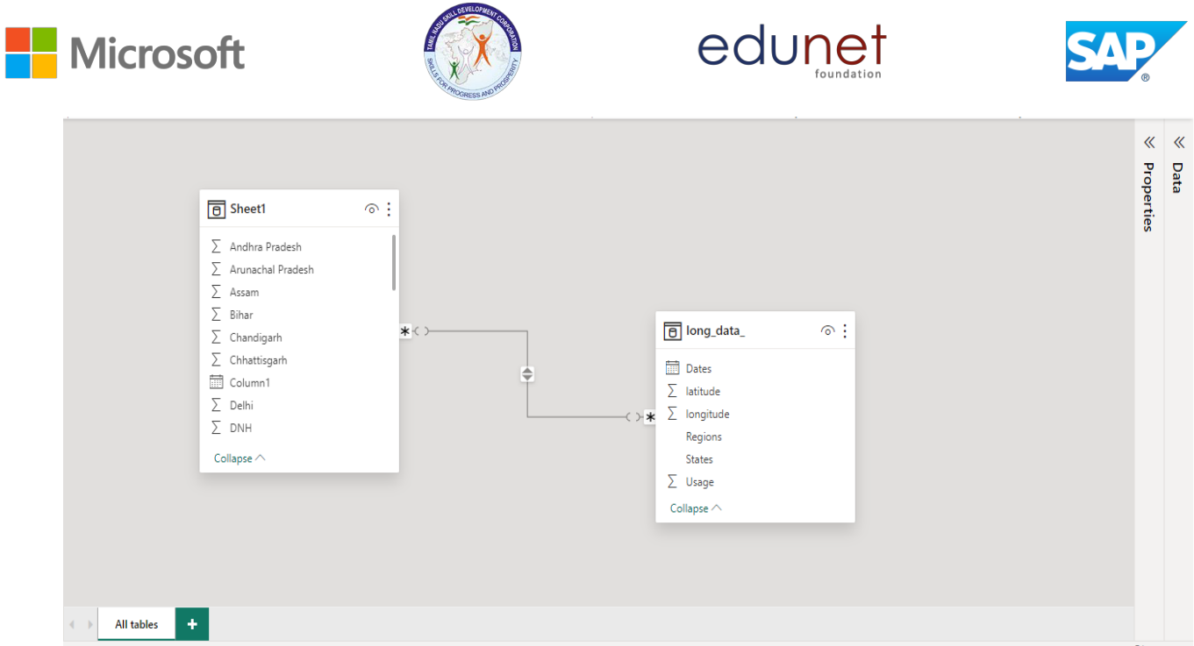

© Edunet Foundation. All rights reserved |6
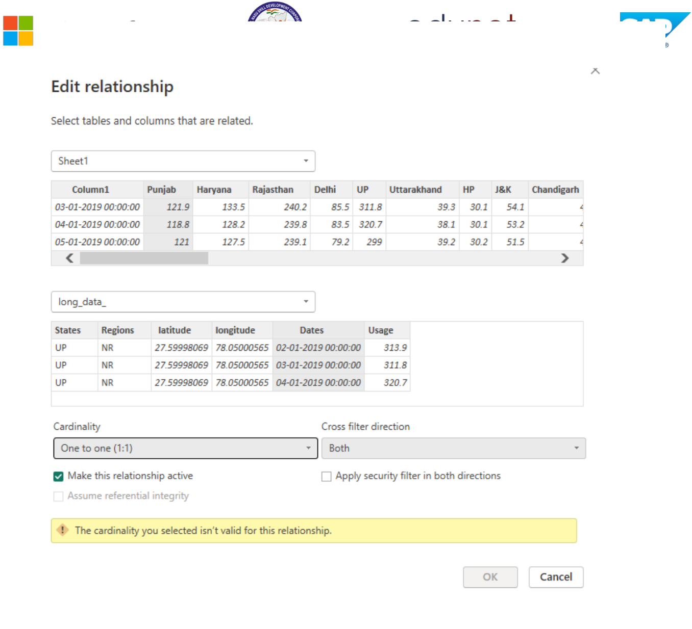

© Edunet Foundation. All rights reserved |7
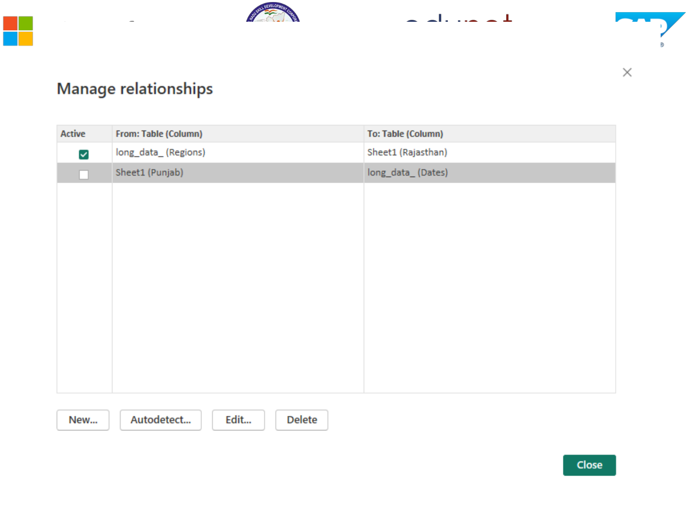

© Edunet Foundation. All rights reserved |8

Dashboard

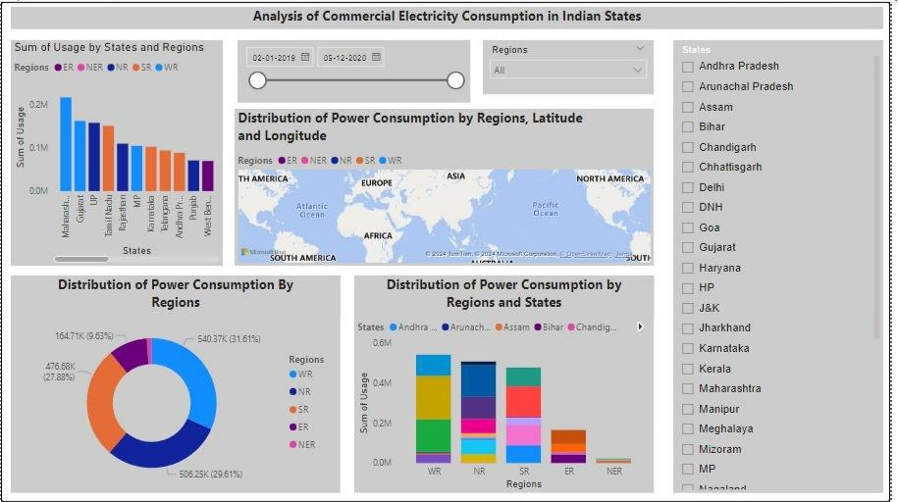

CONCLUSION

To analyze commercial electricity consumption in an Indian state, you would typically need access to data from the state's electricity regulatory authority or utility company. This data should include information on electricity consumption by commercial entities, possibly broken down by sectors such as retail, hospitality, manufacturing, etc. Once you have the data, you can use statistical analysis or data visualization techniques to identify trends, patterns, and insights into commercial electricity usage in the state. Additionally, you might want to consider factors such as economic activity, population density, seasonal variations, and government policies affecting energy consumption.

© Edunet Foundation. All rights reserved |9

FUTURE SCOPE

Analyzing commercial electricity consumption in Indian states using Power BI presents a promising avenue for gaining actionable insights into energy usage patterns. Through historical trend analysis, regional comparisons, and demand forecasting, stakeholders can identify opportunities for efficiency improvements and strategic infrastructure investments. Furthermore, integrating data on building characteristics allows for targeted interventions to enhance energy efficiency and reduce costs. By conducting cost-benefit analyses and assessing carbon footprints, policymakers and businesses can make informed decisions about resource allocation and sustainability initiatives. Segmenting consumption data by industry sectors enables tailored strategies to promote energy efficiency across diverse economic activities. Through interactive dashboards and predictive maintenance models, stakeholders can visualize key metrics and anticipate maintenance needs proactively. Evaluating policy effectiveness and refining initiatives based on consumption trends ensures continuous progress towards sustainable energy practices and economic development.

© Edunet Foundation. All rights reserved |10

REFERENCES

https://ijaísct.co.in/Papeí9099.pdf

GitHub LINK

© Edunet Foundation. All rights reserved |11

